**HW 08: Usability Testing**

**Objectives:**

In part 1 you will conduct a usability test to evaluate the usability of a website. In part 2, you evaluate the site for accessibility.

**Assignment:**

Part 1 - Conduct a usability test to evaluate the usability of a website.

Part 2 - Test the accessibility of the site

**Author:** Prateek Singh Chauhan Honor

**Pledge:** “I pledge on my honor that I have not given or received any unauthorized assistance on this assignment/examination. I further pledge that I have not copied any material from a book, article, the Internet, or any other source except where I have expressly cited the source.”

**Part 1:**

**Website:** <https://moneyconvey.com/>

**Description:** Company official website with company information, contact info with Links to various newsletters.

1. Describe your experimental method, e.g. what approach did you use? What questions did you ask?

**Step 1:** For the experiment, I formulated the features that needs to be tested.

Features to be tested:

* Access to menu
* Effects, Transitions and Animations on the website
* Color scheme of the website
* Clarity of the buttons and information
* Transition between pages
* Time to respond
* Chat Bot Feature

**Step 2:** Once I had all the feature that needed to be tested, I formulated a scenario/task for the user.

Scenario for testing:

User needs to open the website, go through all the information and pages, and at the end subscribe to the news, events and join the Money Convey team.

**Step 3:** Based on the scenario, generated the questions that user will use to rate/scale the website and is required by the website owners to interpret the user experience and make changes based on it. Used John Brooke's System Usability Scale.

Questions:

* 1. I think that I would like to use this system frequently.
  2. I found the system unnecessarily complex.
  3. I thought the system was easy to use.
  4. I think that I would need the support of a technical person to be able to use this system.
  5. I found the various functions in this system were well integrated.
  6. I thought there was too much inconsistency in this system.
  7. I would imagine that most people would learn to use this system very quickly.
  8. I found the system very cumbersome to use.
  9. I felt very confident using the system.
  10. I needed to learn a lot of things before I could get going with this system.

**Step 4:** Conduct Test. Below Procedure or steps were followed:

* Pre-test questionnaires: gathers information relating to participants’ demographics and interest in blockchain services and blockchain enthusiast.
  + This step is used to narrow down or participant pool to reflect only those who:
    - Are comfortable using the internet
    - Use the internet to find and discover newsletters, looking for blockchain services or increase domain knowledge
* Provide Timeline to use application based on the scenario decided.
* Post-task interviews: gathers reflections and experiences following tasks
* System Usability Scale tests: quantitatively rates and weight users’ reactions and impressions of the prototype

1. Describe the number of subjects

No of subjects: 4 (Age ranging from 20-35 years Normal person)

2 Subjects were Students (Educational Background)

2 Subject from Business (Professional Background)

1. Describe the quantitative data you collected during the testing

All the subjects were able to complete the task successfully. Average time taken to complete the task was 5 minutes.

1. Describe the results of the System Usability Scale

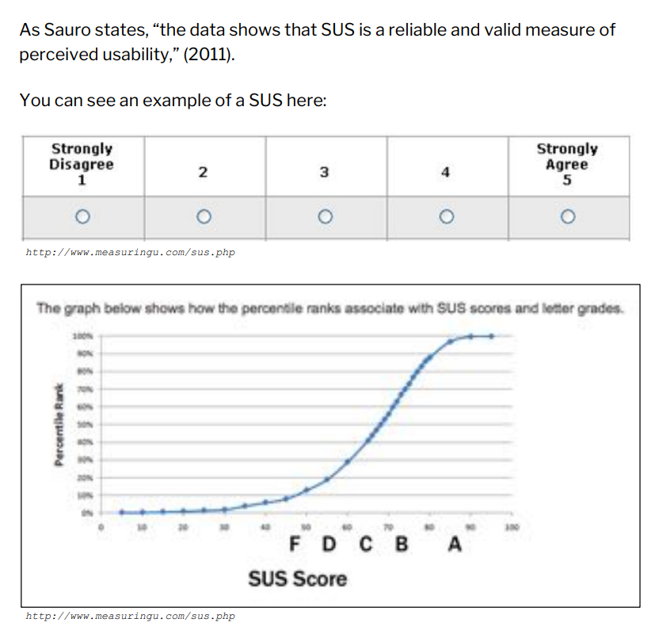

|  |  |  |  |  |
| --- | --- | --- | --- | --- |
| **Questionnaires** | **User 1** | **User 2** | **User 3** | **User 4** |
| I think that I would like to use this system frequently. | 5 | 4 | 4 | 5 |
| I found the system unnecessarily complex. | 2 | 2 | 1 | 1 |
| I thought the system was easy to use. | 4 | 3 | 4 | 4 |
| I think that I would need the support of a technical person to be able to use this system. | 2 | 1 | 3 | 1 |
| I found the various functions in this system were well integrated. | 4 | 4 | 4 | 4 |
| I thought there was too much inconsistency in this system. | 2 | 2 | 3 | 3 |
| I would imagine that most people would learn to use this system very quickly. | 4 | 4 | 5 | 5 |
| I found the system very cumbersome to use. | 1 | 2 | 3 | 3 |
| I felt very confident using the system. | 5 | 5 | 5 | 5 |
| I needed to learn a lot of things before I could get going with this system. | 1 | 1 | 1 | 1 |

Using the above data Calculated the SUS score using online tool: <https://uiuxtrend.com/sus-calculator/>

Below were the results:

|  |  |
| --- | --- |
| **Participant** | **SUS score** |
| 1 | 82.5 |
| 2 | 80 |
| 3 | 77.5 |
| 4 | 85 |
| **Average** | **81.25** |

SUS score will be able to tell you your usability performance in the aspects of effectiveness, efficiency, and overall ease of use.

Interpretation of the SUS score can be done using below table:

Source: <https://uiuxtrend.com/measuring-system-usability-scale-sus/#interpretation>

**Average SUS score is 82.5 which means that the website has excellent useability performance.**

1. Describe the qualitative data including your observations from the experiments.

Post Interview gathered below reflection related to website:

* Website was easy to use.
* All the information conveyed were clear and precise.
* All the animations were clear and not surprising.
* User was able to use the chat bot easily.

Few findings that were observed by the user and needs to be worked upon:

**Findings 1:** Menu does not indicate where which page the user is currently.

Users were confused in the menu as they did not know which page, they were in.

**Recommendation 1:** Menu should indicate what page the user is in.

**Finding 2:** In the mobile version, the menu covered the whole screen, which users did like it as it hides the whole screen making user believe that he did something wrong.

**Recommendation 2:** To change the menu view, instead covering the whole screen, partial screen menu would work.

1. A summary of Part 1 that includes conclusions, if any, and observations, key learnings, reflection

During the usability testing, learned how user interacts with any application and what are the key features or feasibility that needs to be considered while developing, designing, and testing. Useability testing concludes that every application will be used by the User of all kinds and UI/UX functionality needs to design from user mind-set. Usability testing gives an idea about how easy it is to use the application designed and provides insight on how user reacts to every action and helps to maintain the standard of the application as per user perspective.

Also, for Useability testing the strategy is important such as:

* what kind of features are we testing,
* what is expected from the user,
* how the user will be selected based on what user application is targeting (demographics, domain, age),
* what will the measurability indicators,
* what questions needs to be asked to the user,

Based on the results of the usability testing, the application owner can decide the future of the application, by fixing findings, create a new design or by creating a training program for users.

**Part 2:**

**Website:** <https://moneyconvey.com/>

**Description:** Company official website with company information, contact info with Links to various newsletters.

**Tools Used/Ventured:** Below were the tools I tried and tested

**Tool 1: Bulk Accessibility Checker by EXPERTE.com**

Bulk Accessibility Checker crawls a website and automatically checks the accessibility of each subpage. This helps to find accessibility issues on the whole website, not just on a single page.

**How does it work?** This tool is a website and requires only the home URL of the website and bulk accessibility checker generates reports all the pages including all the child pages of the website and the reports are downloadable.

**Ease of Use:** **5/5**

**URL**: https://www.experte.com/accessibility

**Tool 2: Accessibility Checker by Intent Base**

A free web-based audit tool that scans your website for current WCAG standards. Its uniqueness is the presentation of the errors it finds on your website. For every error the scanner finds, you will receive a detailed explanation about it, whom it affects and multiple options on how to solve it.

**How does it work?** This tool is a website and requires only the home URL of the website and bulk accessibility checker generates visual reports only for the URL mentioned (not includes child pages) and the reports are downloadable.

**Ease of Use:** **4/5**

**URL:** https://www.accessibilitychecker.org/audit/?website=https%3A%2F%2Fmoneyconvey.com%2F&flag=us

**Tool 3: Accessibility Insights for Web by Microsoft**

Accessibility Insights for Web is a Chrome extension that helps developers find and fix accessibility issues in web apps and sites.

**How does it work?** This tool is a plug in for the chrome and plugin needs to be activated for the website that needs accessibility testing.

**Ease of Use:** **3/5**

Out of the 3 tools I researched, the **Bulk Accessibility Checker by EXPERTE.com** was easier to use and provided all the reports in csv format and included all the child pages.

**Test Results:**

* Score and testcases passed for each page:





* Issues For each page:





Conclusion of Accessibility test:

|  |  |  |
| --- | --- | --- |
| Issue | Description (of what needs to be fixed) | Count |
| Image elements do not have `[alt]` attributes | Informative elements should aim for short descriptive alternate text;Decorative elements can be ignored with an empty alt attribute. [Learn more](https://web.dev/image-alt/). | 2 |
| Heading elements are not in a sequentially-descending order | Properly ordered headings that do not skip levels convey the semantic structure of the page making it easier to navigate and understand when using assistive technologies. [Learn more](https://web.dev/heading-order/). | 3 |
| Links do not have a discernible name | Link text (and alternate text for images when used as links) that is discernible unique and focusable improves the navigation experience for screen reader users. [Learn more](https://web.dev/link-name/). | 2 |
| Heading elements are not in a sequentially-descending order | Properly ordered headings that do not skip levels convey the semantic structure of the page making it easier to navigate and understand when using assistive technologies. [Learn more](https://web.dev/heading-order/). | 1 |

Also, including reports generated from other tools:

**Tool 2: Accessibility Checker by Intent Base**



**Tool 3: Accessibility Insights for Web by Microsoft**



**Reflection and understanding:** Accessibility test provides the insight on how the website is accessible to the user. The test is needed to understand how the application will be used by the user and how informative and available is the website to the user who can be normal person or challenged person as well.

**Challenges faced:** All the tools give different reports with different visualization but ultimately conveying same information.